New project.
Investment Analysis
- How much money has the company made in the past? Revenue 2021-2024
- How much money they might make in the future?
- If they build another factory than how much will that factory earn? Each year
- Was the. Money spent on the factory worth it. Initial investment vs the returns
- What if our prediction is wrong? Multiple factors like inflation etc
Step 1: THE PROBLEM
If someone asks for a 500 million investment to build a factory, as a CEO what would I ask?
- Will this make me money?
- How long would it take for us to recover the initial investment?
- Is it risky?
- What will happen If the sales are lower? Or what if we cannot recover our investment?
- Is there a better option?
Ill build a model tool that helps to evaluate if an investment is worthy using historical company data, prediction and financial analysis.
Step 2: Who will I present this problem?
CFO/ investment manager
Step 3: How will my app work?
User will open it -> choose their company -> enter information such as the investment amount, project length etc. -> click analyze - > get result.
Step 4: What information goes in the app?
- Company’s Information (from the internet)
- Revenue
- Cashflow
- Net income
- Capital expenditure
- Project Information (entered by the user)
- Initial investment
- Project duration
Step 5: What will my program do?
- Get the company's historical financial data.
- Clean and organize the data.
- Estimate future performance.
- Evaluate the proposed investment using financial formulas.
- Test different possible future scenarios.
- Summarize the results.
Step 6: What comes out?
For example:
📈 Revenue forecast
💰 Estimated cash flows
📊 NPV
📉 IRR
⏳ Payback period
🎲 Risk analysis
✅ Recommendation
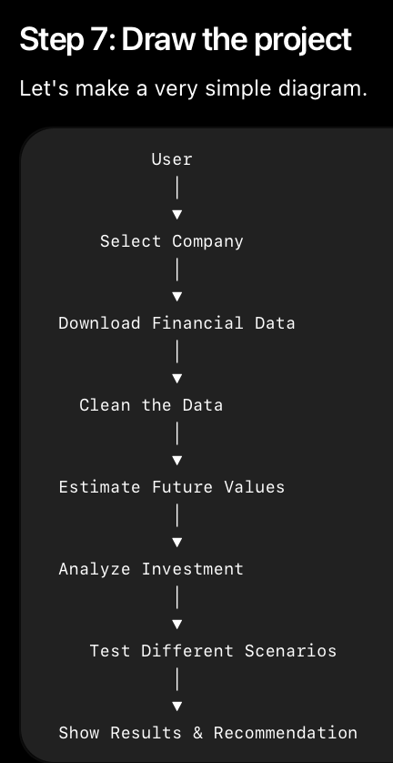
A decision support tool that analyzes historical financial data, evaluates uncertainty, and explains the potential risks and rewards of a proposed investment so decision-makers can make more informed choices.
I'm building a decision support system that helps finance professionals evaluate investment opportunities by combining historical company data, forecasting, financial analysis, and risk scenarios. The system does not make the decision—it explains the evidence so the user can make an informed one.
Basically, the app works as an assistant to support your decisions to why or why not your investment would be worthy.
Also its not predicting investment decisions but predicts future financial performance, and that information helps people make investment decisions.
Why can’t someone just use excel? (the key to answer such questions is not to make excel look bad but make your app look good)
For example my app would:
- It automatically downloads company data.
- It automatically cleans the data.
- It automatically generates forecasts.
- It automatically runs thousands of simulations.
- It automatically visualizes the results.
- It produces a repeatable workflow with less manual effort.
That's the value.
You are not trusting my recommendation; you are making the decisions yourself and I'm only putting out to you why or why not the investment would be worthy.
Here is the evidence. Here are the risks. Here are the possible outcomes. You decide.

